Downham Market Town Hall Booking Form
Bookings are not confirmed until we have received all forms returned / completed and payment of the deposit.
About You

Organisation/Business/Hirers
Name:
Your Address:

Invoicing Address:
(if different from above)
Email address:
Telephone Number:
Mobile:

About your event

Event Name: Please provide details of event: Type, if alcohol will be on premises, ticket selling etc. |  |  |  |  | Security booked  (Please contact us for details of our preferred security companies for Town Hall
 |  |  |  |  | Bar booked - (Please contact us for details of our Licensee for the Town Hall)
Date/s:
No. of attendees |  |  | Start: |  |  | Ends:

Which room/s do you wish to book? Please tick all that apply.

Clock Room
Assembly Room
Will kitchen be required (Grand Hall only)?
Grand Hall

Your room/equipment requirements

Theatre | 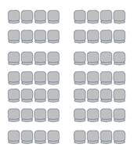 | Meeting
Boardroom |  | Classroom | 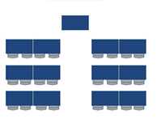
Cabaret Standard | 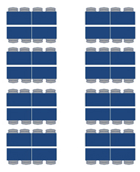 | Cabaret Premium | 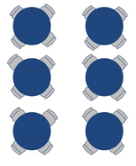
Other Layout
***Please note, no changes to layout 72 hours prior to booking date***
Modular Staging  Yes / No | Hot Water Flask FOC  Yes / No |  | Tiered Seating  Yes / No
Cups/Saucers  How many? | Drapes FOC  Yes / No |  | Chairs  How many?
Round/Circular tables  Large: 10 (seats 8ppl) Small: 8 (seats 4ppl)  How many? |  | Rectangle Tables  Upstairs: 8 / Downstairs: 27  How many?

Should you require a Disco, Lighting, Sound, or Microphone, this can be arranged through J R Light & Sound. A price list can be found on the Downham Market Town Council website.
I certify that I have read, understood, and agree to the ‘Terms and Conditions of Hire’, ‘Bar Provider Details’ ‘Fire and Emergency Procedures ‘and the ‘GDPR Policy’, copies of which have been found on the Town Council website or have been provided to me upon request.
Signature
Print
Date

Downham Market Town Hall Prices & Capacity
Room | Charge
Grand Hall (Capacity 280 people, 150 seated)  Also includes use of the main kitchen | Per hour: £24.80  All Day (8am – Midnight)  £248.00
Clock Room (Capacity 70 people seated)  For weddings 68 + 2 Registrars | Per hour: £14.00  All Day (8am – Midnight)  £140.00
Assembly Room (Capacity 70 people seated)  For Weddings 68 + 2 Registrars | Per hour: £14.00  All day (8am – Midnight)  £140.00
Entire Building (Grand Hall, Clock Room & Assembly Room) | Per hour: £48.00  All Day (8am – Midnight)  £480.00
Tiered seating/staging | Fixed Price £100
Further discount of 10% available for bookings of more than 7 consecutive days

Deposit payable to secure booking
Total Hire Charge | Amount Payable on Booking | Amount Payable 4 weeks Prior to Hire
Total Charge £100 or less | £25 | Balance of Full amount
Total Charge £101 - £199 | £50 | Balance of Full amount
Total Charge £200 - £499 | £100 | Balance of Full amount
Total Charge of £500 -£999 | £200 | Balance of Full amount
Total Charge in excess of £1000 | £250 | Balance of Full amount

In addition
A returnable deposit of £150.00 will be required to cover damage and breakages.

If your set up includes tables, tiered seating, a bar or disco, the capacity may reduce. Please contact us to confirm Fire Safe Capacity. If you exceed the Fire Safe Capacity regulations, your event will be cancelled, or paused until the excess number sleave the building. Please note that there will be no refund provided.

For more information contact DMTC on: Tel: 01366 387770 or email info@downhammarkettc.co.uk
FOR OFFICE USE ONLY
Proof of Public Liability Provided Yes/No
Total Amount Paid
Date Booked and Paid
Receipt No

